**Diagrams**

1. **Sequence Diagram**

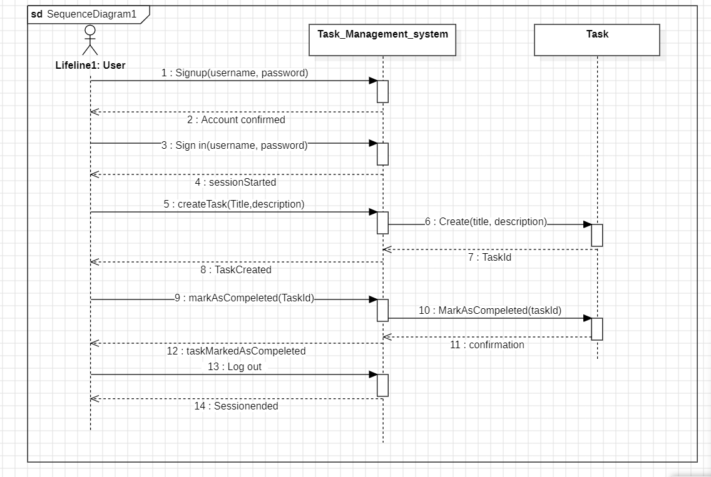

1. **Class diagram**

1. **Use case diagram**

